**Report For Runlinc**

**(A case study for AI Object Recognition Library)**

By

Afolayan Oluwatimilehin Israel

080-452

**Introduction**

Object recognition is one of the amazing applications of AI applied to camera or video. By real-time recording a video, we can recognize if an object on a camera is human or otherwise. This can help immensely for security reasons. Imagine the possibilities of the world with this technology. However, in this project, rather than coding object recognition from scratch, we will introduce you to a library that has already been made by others that we can use for object recognition.

The Library: MobileNets: small, low-latency, low-power models parameterized to meet the resource constraints of a variety of implementation cases. They can be built upon for classification, detection, embeddings and segmentation similar to how other popular largescale models, such as Inception, are used. MobileNets trades off between latency, size and accuracy while comparing favorably with popular models from the literature. This TensorFlow model does not require you to know about machine learning. It can take as input any browser-based image elements (, , elements, for example) and returns an array of most likely predictions and their confidences.

**Visual Content**

Below is the screenshot of all codes used:

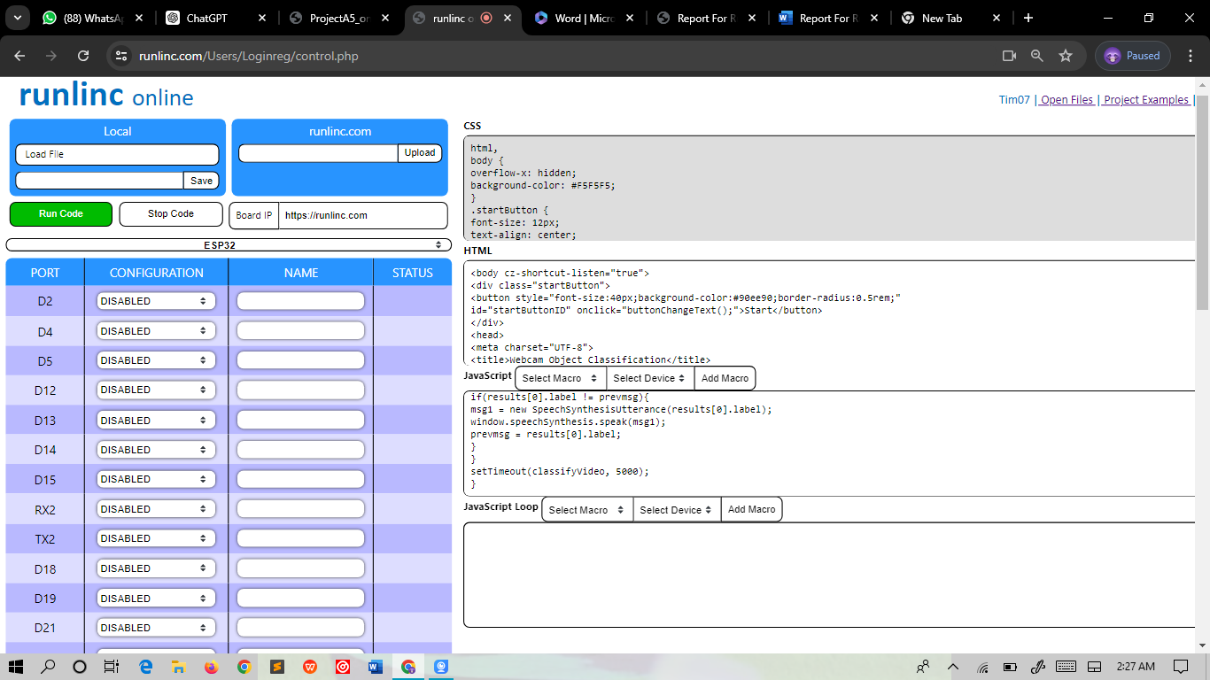

**HTML codes:**

<body cz-shortcut-listen="true">

<div class="startButton">

<button style="font-size:40px;background-color:#90ee90;border-radius:0.5rem;"

id="startButtonID" onclick="buttonChangeText();">Start</button>

</div>

<head>

<meta charset="UTF-8">

<title>Webcam Object Classification</title>

<script src="https://cdnjs.cloudflare.com/ajax/libs/p5.js/1.9.1/p5.min.js"></script>

<script src="https://unpkg.com/ml5@latest/dist/ml5.min.js" type="text/javascript"></script>

</head>

<body>

<h1>Webcam Object Classification</h1>

</body>

**CSS codes:**

html,

body {

overflow-x: hidden;

background-color: #F5F5F5;

}

.startButton {

font-size: 12px;

text-align: center;

margin: 1%;

}

h1 {

font-size: 40px;

font-family: "Lucida Sans Unicode", "Lucida Grande", sans-serif;

}

p {

font-size: 20px;

font-family: Arial, Helvetica, sans-serif;

}

**JavaScript Codes:**

html,

body {

overflow-x: hidden;

background-color: #F5F5F5;

}

.startButton {

font-size: 12px;

text-align: center;

margin: 1%;

}

h1 {

font-size: 40px;

font-family: "Lucida Sans Unicode", "Lucida Grande", sans-serif;

}

p {

font-size: 20px;

font-family: Arial, Helvetica, sans-serif;

}

**OUTPUT**

